Para bank

Design Document

Approval

|  |  |
| --- | --- |
| Title | |
| Issue Number 0.1 | Revision Number 0.1 |
| Author Bharath | Date 18/01/2022 |
| Approved By Bharath | Date of Approval 18/01/2022 |
|  |  |

Change Log

|  |  |  |  |
| --- | --- | --- | --- |
| Reason for change | Issue Nr. | Revision Number | Date |
|  |  |  |  |

Change Record

|  |  |  |  |
| --- | --- | --- | --- |
| Issue Number | Revision Number | | |
| Reason for change | Date | Pages | Paragraph(s) |
|  |  |  |  |

Distribution

|  |
| --- |
| Name/Organisational Unit |
|  |

Table of contents:

1 Introduction 4

2 User Needs and user RequiremEnts 4

User Needs 4

User Requirements 4

3 System Requirements 6

System Requirements 7

This document is intended to serve as guideline for preparing the Requirements Document in the frame of an ARTES Applications Project.

# Introduction

The Design Document (RD) is dedicated to providing a comprehensive set of app design and architecture to the Para bank project together with the relevant justifications.

# User Needs and user RequiremEnts

## User Requirements

This part is describing in a structured form the set of statements originated by the users describing the functions, performance and capabilities that the system will bring to them during its utilisation. A mapping between User Requirements and User Needs is part of this section.

| **ID** | **User Need** | **Source** |
| --- | --- | --- |
| PAR-001 | Login Page to allow valid users to access the application | N/A |
| PAR -002 | Welcome Page to accommodate all application menus | N/A |
| PAR -003 | Forgot Password Page to reset the password | N/A |
| PAR -004 | Registration page to sign-up for new account | N/A |
| PAR-005 | New account opening page | N/A |
| PAR-006 | Account overview page to get customer account information | N/A |

Table 1 – User Requirements

**Application Design**

Any Application design shall be defined on the basis of the following rules.

**PAR-001 Login Page to allow valid users to access the application**

✓ Para bank Logo should be there

✓ It should have Username, Password Textboxes and Login Button

✓ It should have option to reset the login information

✓ It should allow only registered users

✓ It should have option to create new account

**Application Logo**



**Login page design**

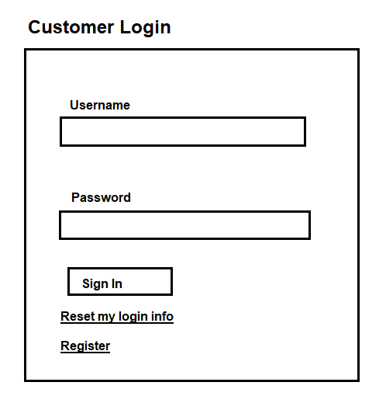

**PAR -002 Welcome Page to accommodate all application menus**

Home Page should have multiple menus with all the relate information

1. Solutions

2. About Us

3. Services

4. Products

5. Locations

6. Admin Page

7. ATM Services

8. Online Services

9. Latest News

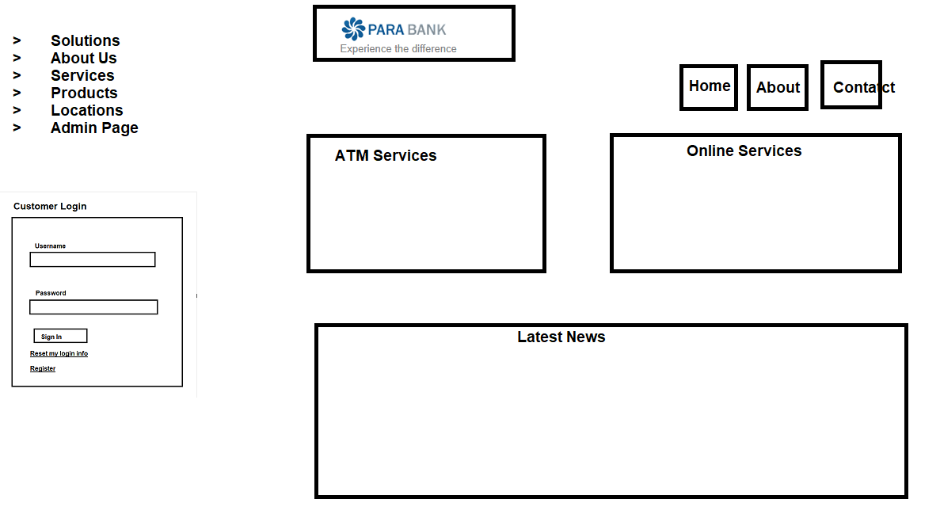

**PAR -003 Forgot Password Page to reset the password**

Forgot password page should have texts field to update customer information and reset the password

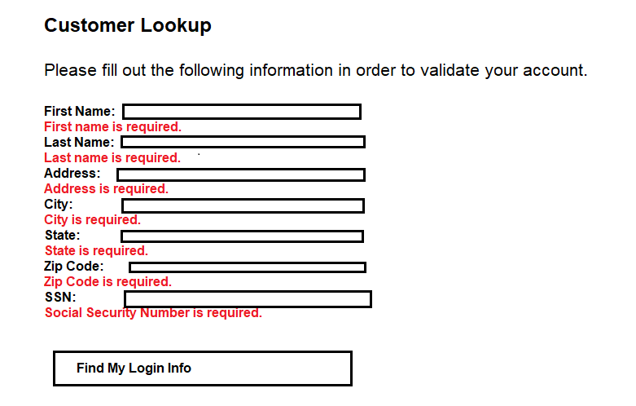

**PAR -004 Registration page to sign-up for new account**

Registration page should have valid fields to collect customer information and user should be able to create new account

